Information on tourist spots around Ojiya

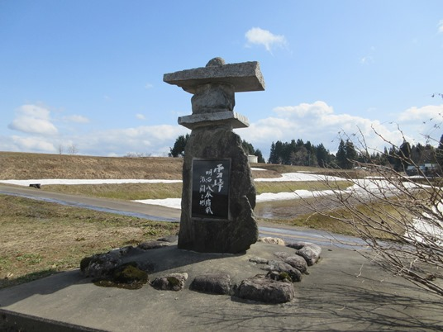
Imozaka/Yuki-tōge Monument of Fierce Battlefield

In 1868, there was a fierce battle called “the battle of Hokuetsu” in Niigata. On June 16, it started at Yuki-tōge which was a strategically important point located between Imozaka and Ikegahara. It seemed the eastern army had an advantage over the western army geographically even though the western army had few times more troops than the eastern army did. However, the eastern army were defeated by some troops of the western army that detoured Yuki-tōge.
In 1995, a monument by local volunteers was placed by a prefectural road in Ikegahara. It will hand the historical battle down to new generations to come.

Episodes
- When an old house in a village at Yuku-tōge was demolished in around 1955, an iron bullet was found inside the roof. It is said it was a gunshot by the western army.
- When Japanese National Railways carried out construction of the Shinano River Power Plant in 1950, a cave-in happened near east side of Yuki-tōge and about 40 people lost their lives. People thought it was an act of spirits of those who died in the battle at Yuki-tōge. At that time, it was handed down “be careful with the spirits when passing Yuki-tōge”.

